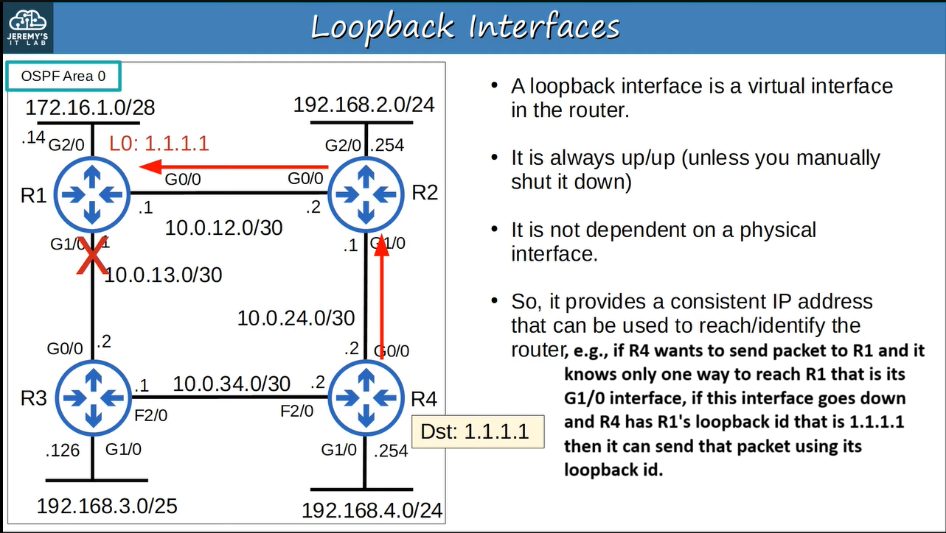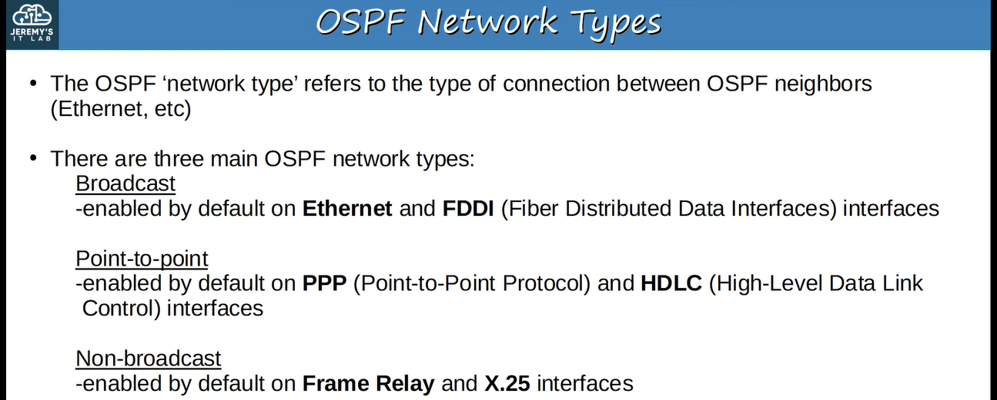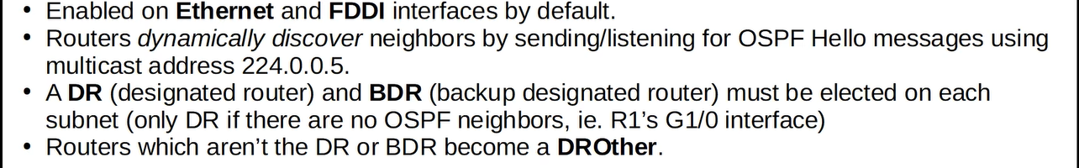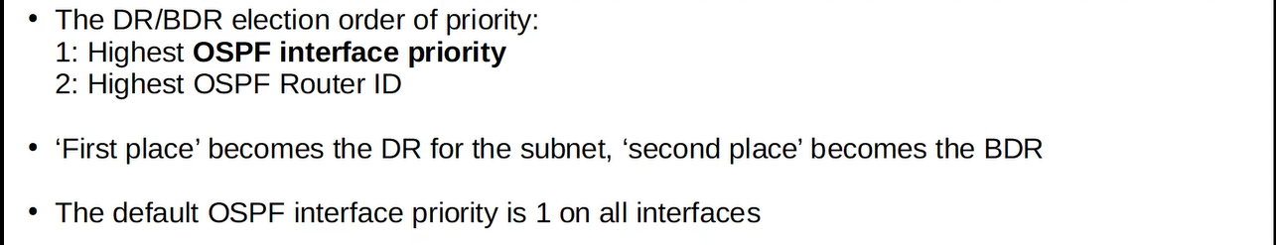

**e.g., ↓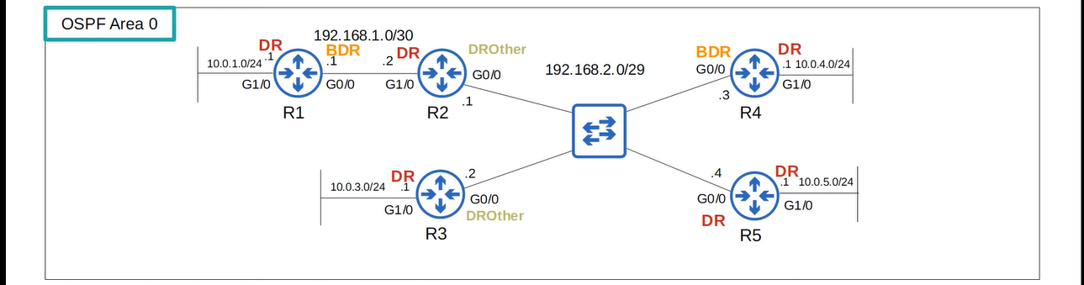You can check using the command “show ip ospf interface** interface**” ↓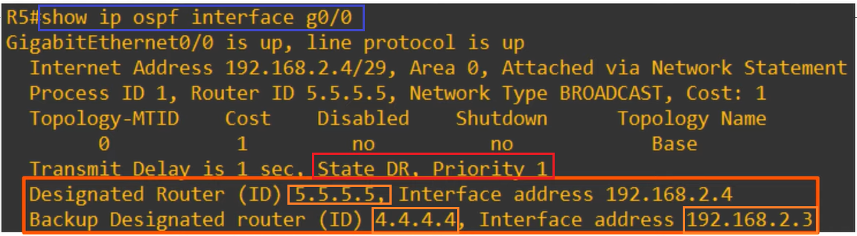Similarly ↓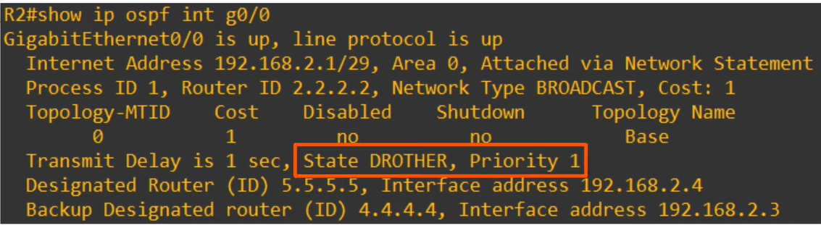We can change the OSPF interface priority, e.g., ↓let’s see the state on R2 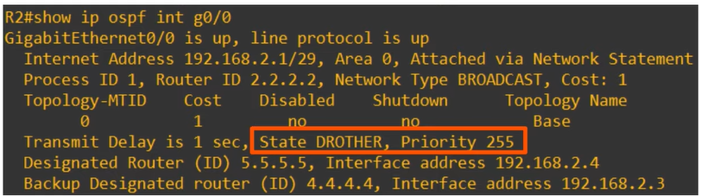 the state did not change, because ↓after reset the R5, R4 will become the new DR because it was BDR and then the election will be held between other routers for the new BDR and R2 will become the new BDR, because it has it has highest priority ↓**

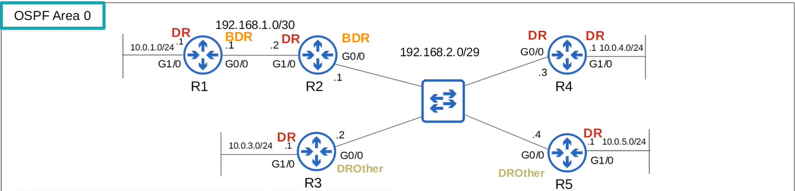**Remember, the BDR becomes the new DR if the current DR is removed even if it does not have the highest priority and the DROthers don’t form full adjacencies with other DROthers they remain in the 2-way state 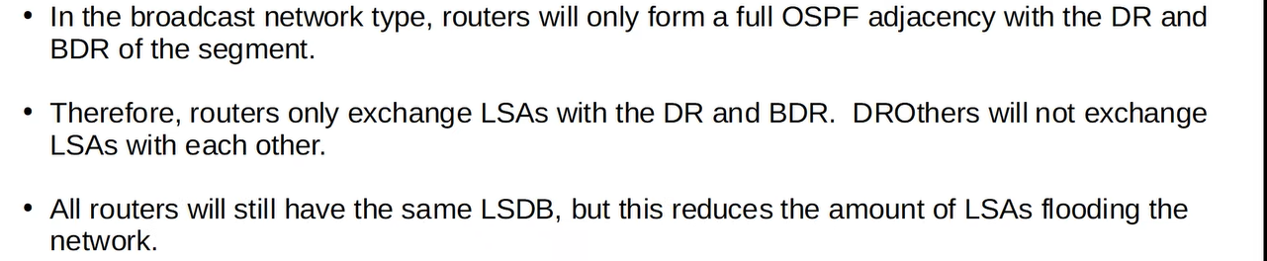e.g., without using DR and BDR, routers will flood the LSAs like this ↓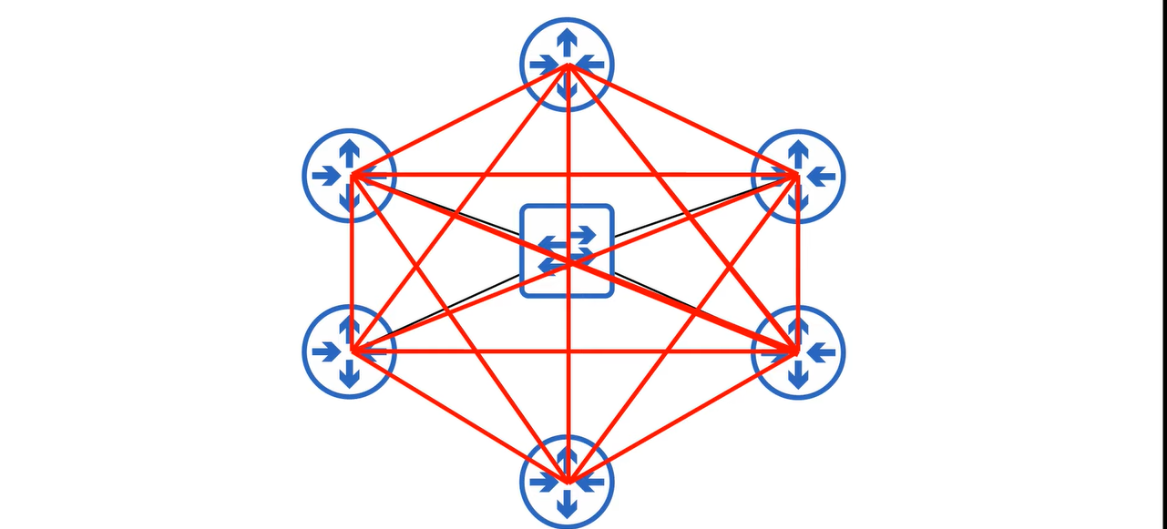 on using DR and BDR, routers will flood the LSAs like this ↓**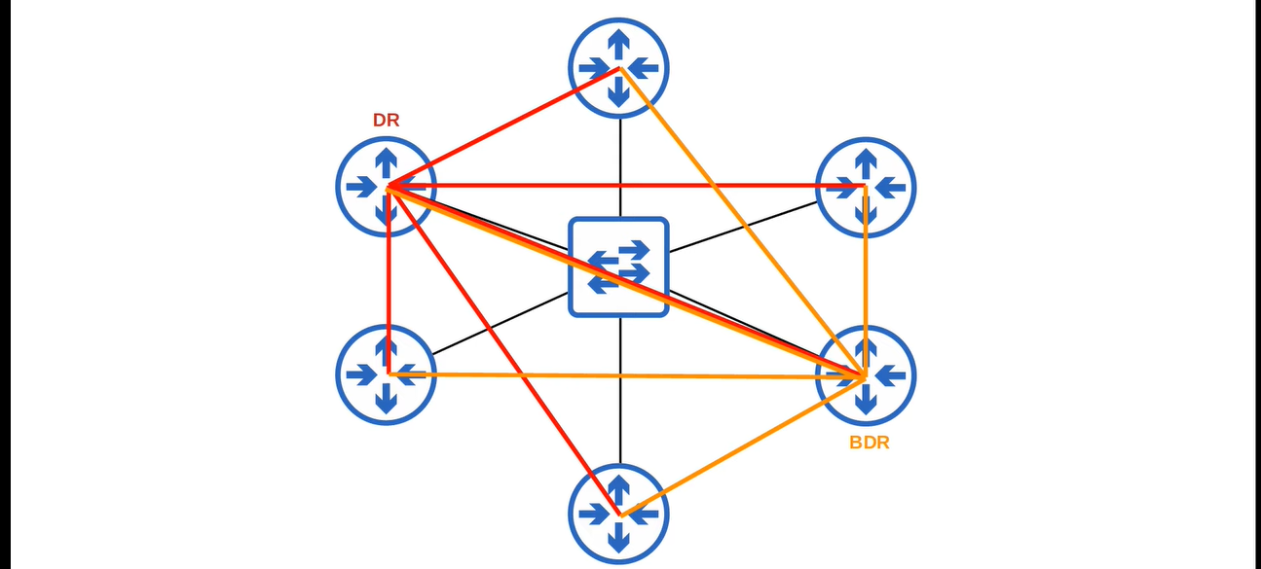

**e.g., ↓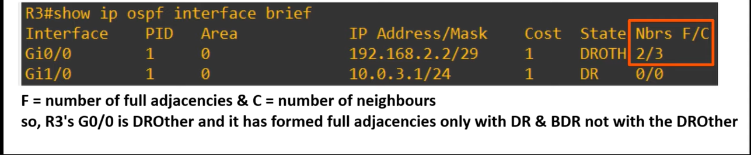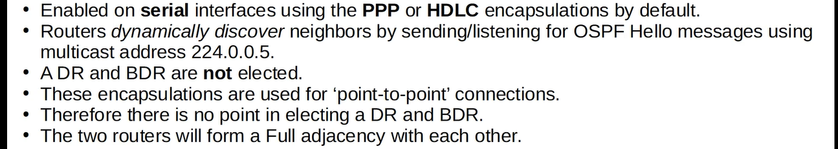e.g., ↓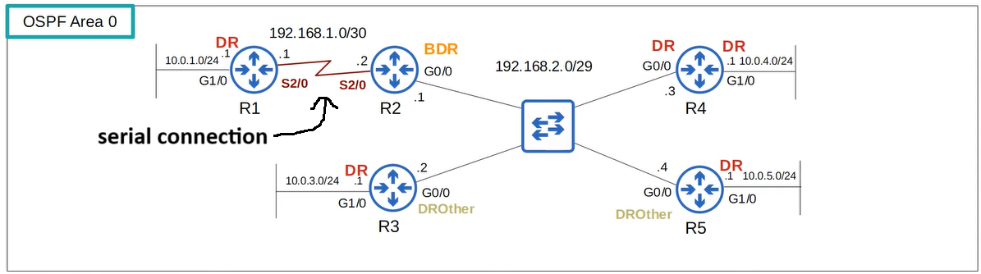Configuration for PPP ↓**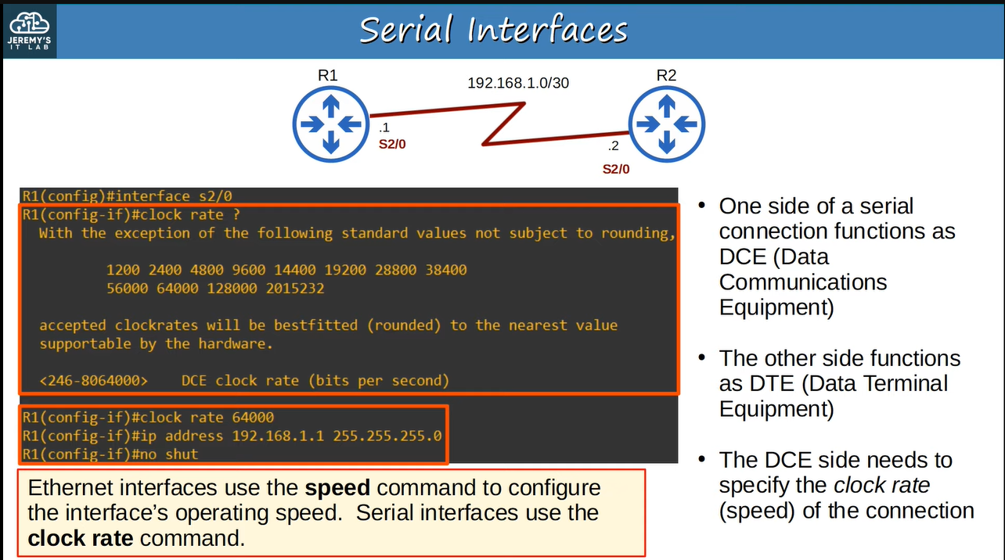

**How to know which side is DCE and which is DTE ? ↓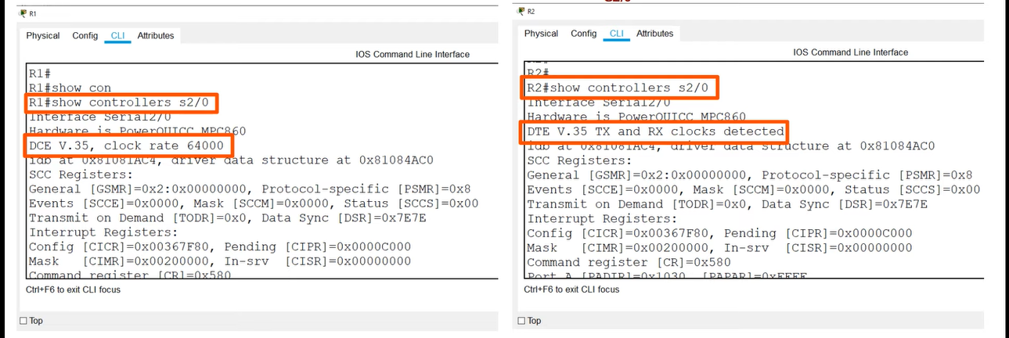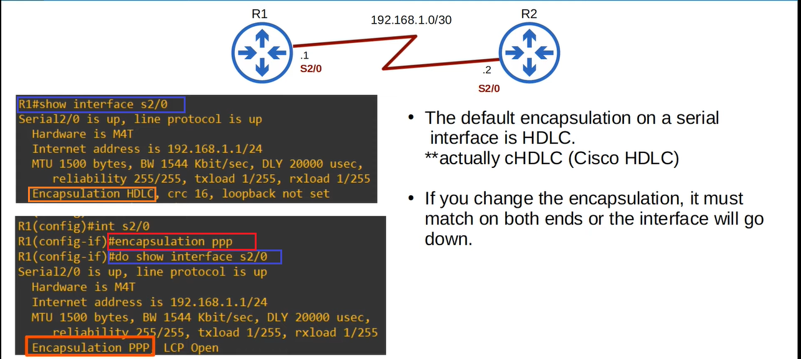Running configuration of R1 & R2 ↓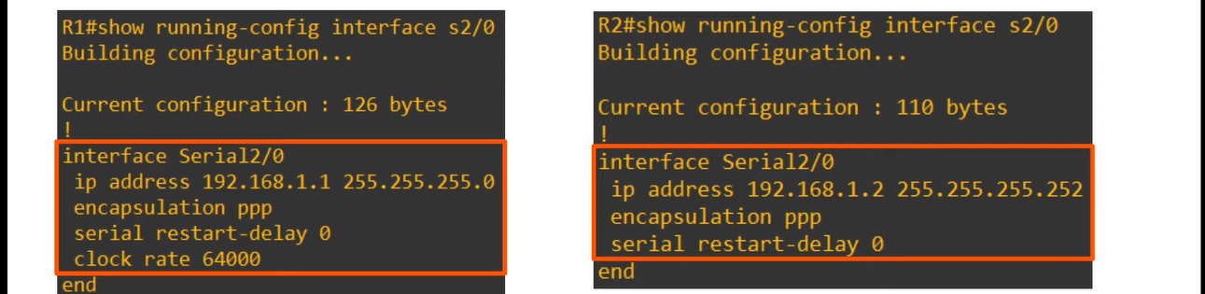cHDLC frame structure ↓**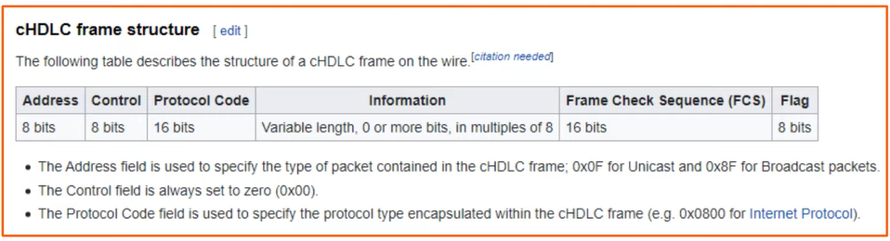

**Summary ↓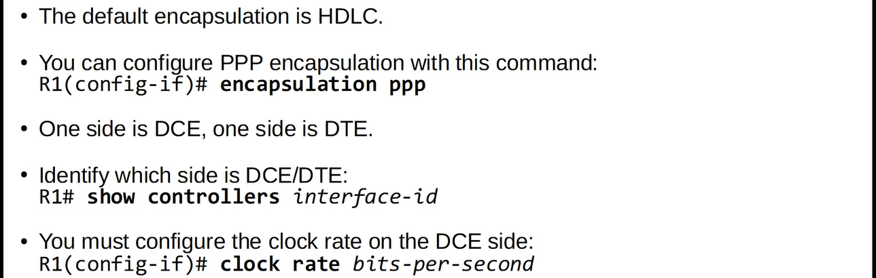As we mentioned above, in PPP, there is no DR & BDR, you can see ↓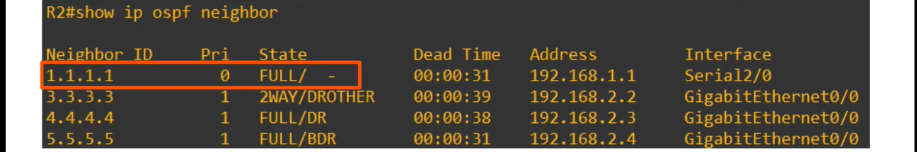We can manually configure the network type an interface** 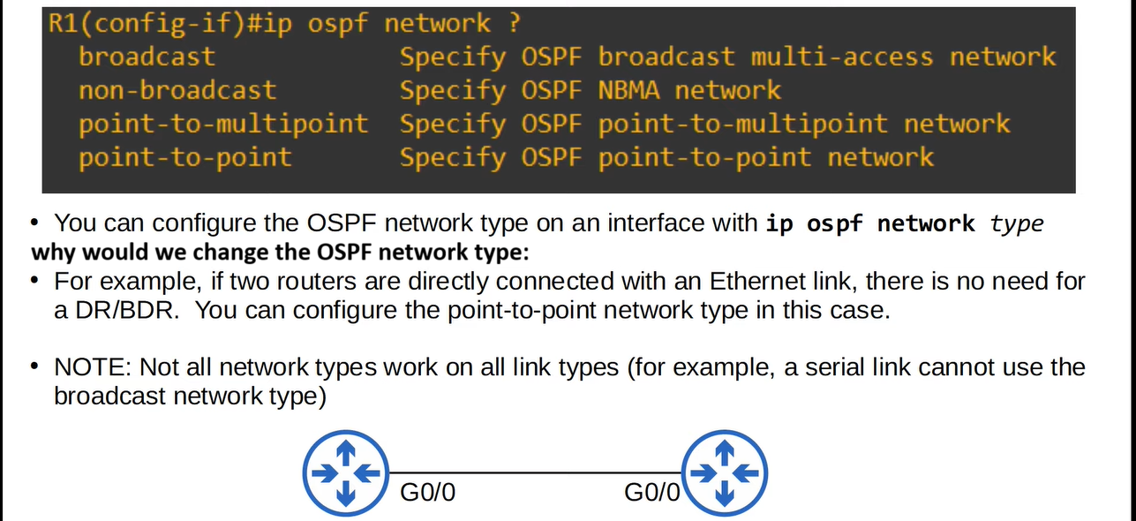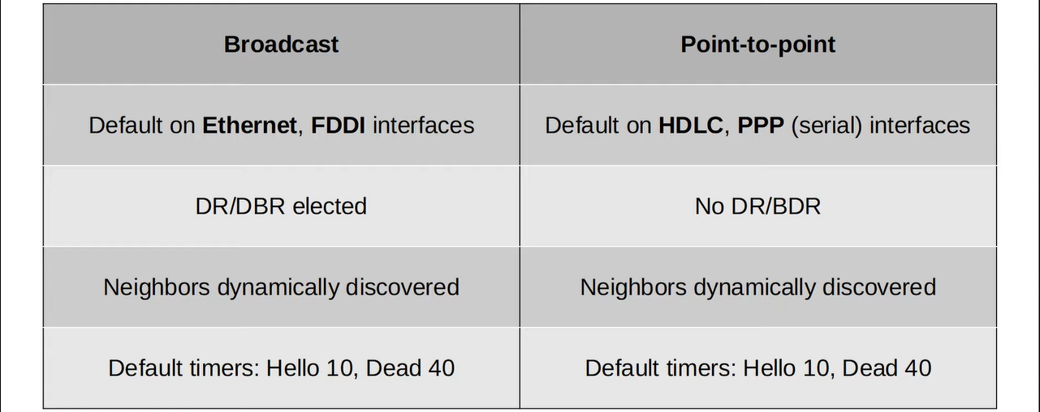

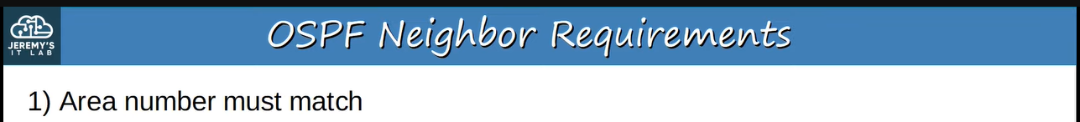**e.g., ↓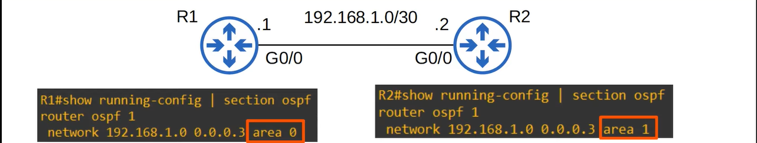both are in different areas, so they have no OSPF neighbours as you can see ↓we will fix this issue ↓now they have OSPF neighbours as you can see ↓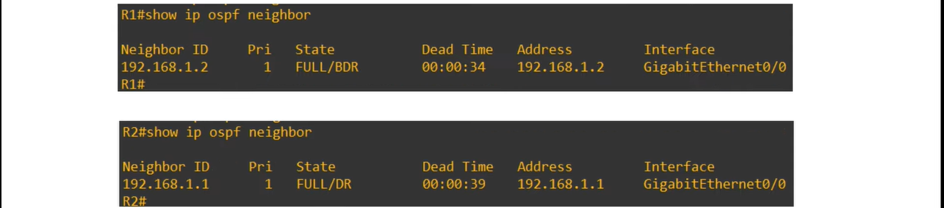e.g., ↓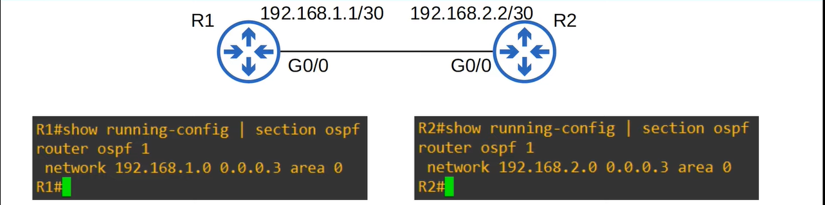 both are in different subnets, so they have no OSPF neighbours as you can see ↓ we will fix this issue ↓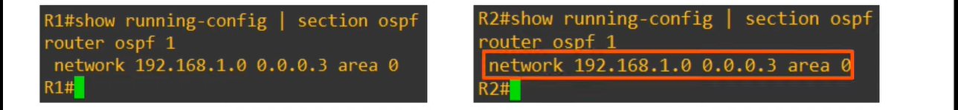 now they have OSPF neighbours as you can see ↓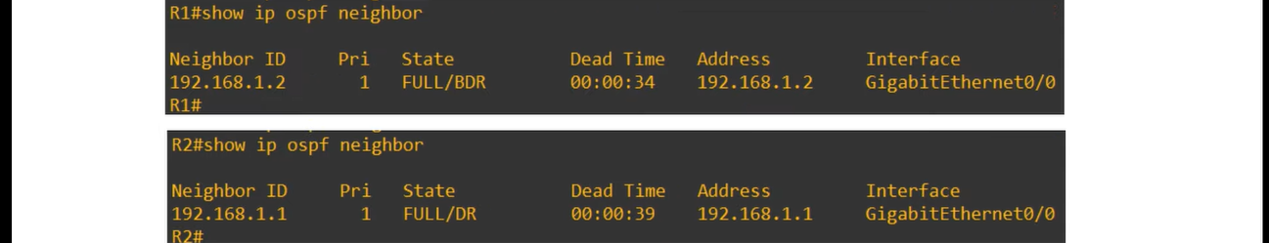e.g., ↓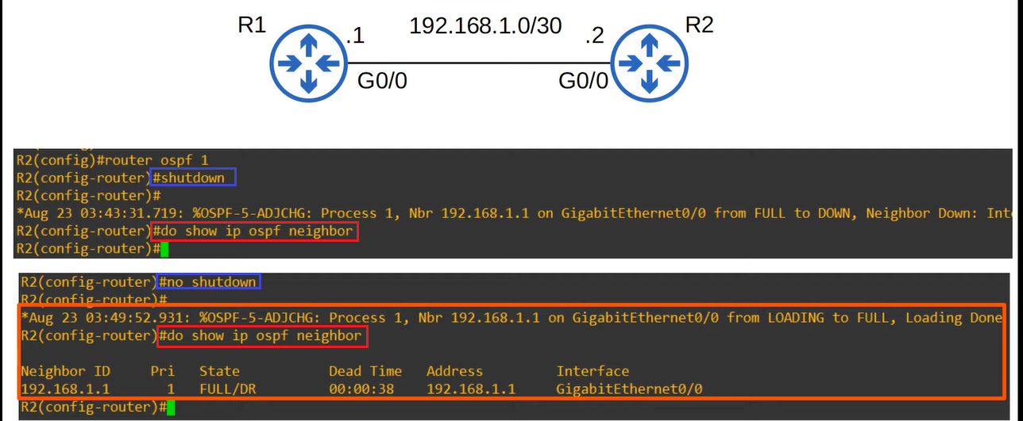e.g., ↓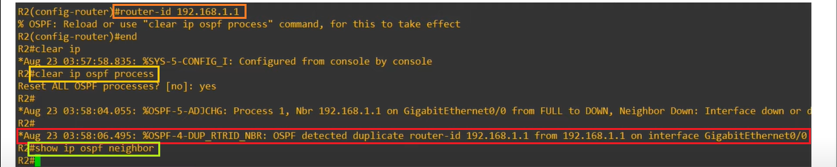you can see, after assigning R1’s G0/0 IP address to R2’s G0/0, it has no OSPF neighbour, so, we will fix it ↓**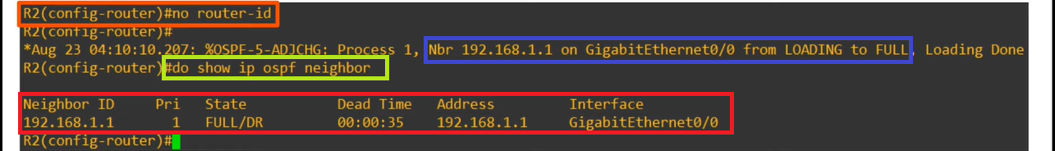

**e.g., ↓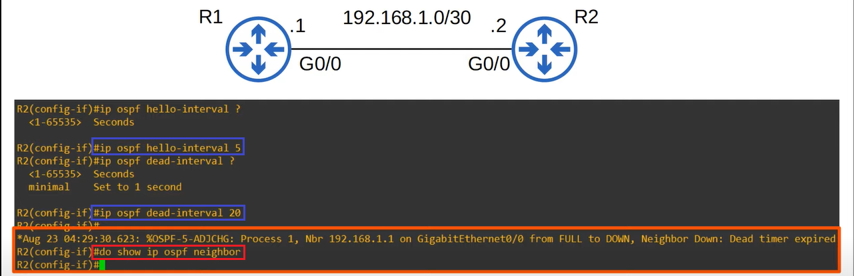after setting different intervals of time for hello-interval and dead-interval, there is no OSPF neighbour, now we will fix it ↓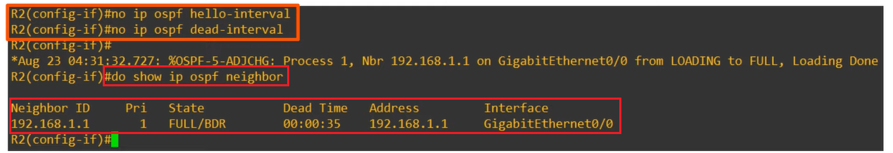e.g., ↓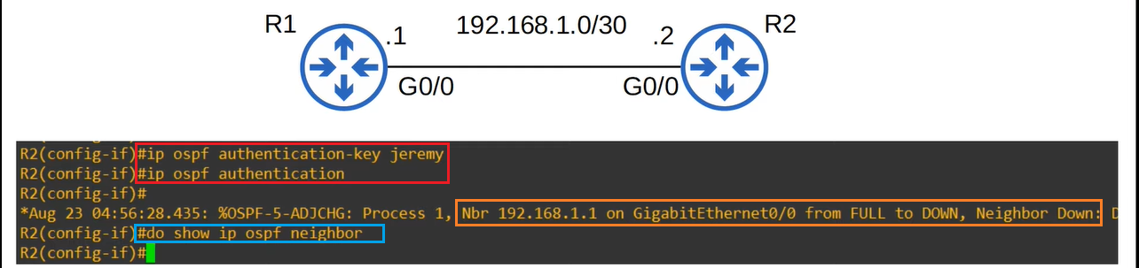to fix it, we will have to configure same authentication setting on R1 or to remove the authentication from R2, so ↓**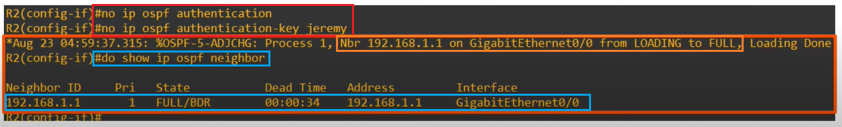

**by default, it is 1500 bytes, but it can be configured. Remember, if this does not match then they can become OSPF neighbours but OSPF does not operate properly, e.g., ↓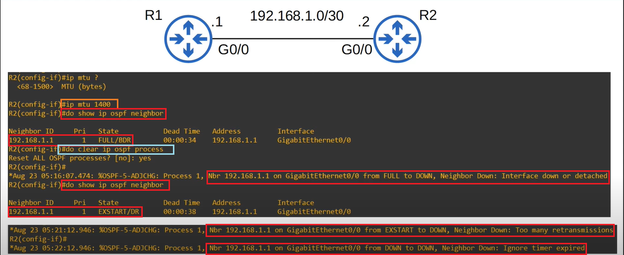 to fix it, we can do same configuration on R1 or we can delete this configuration from R2 ↓in this also, if this does not match then they can become OSPF neighbours but OSPF does not operate properly. If we create a loopback on R2 and advertise it to R1, there is no big problem in OSPF but the R1 will not add the loopback address in its routing table due to mismatch the network type, e.g., ↓**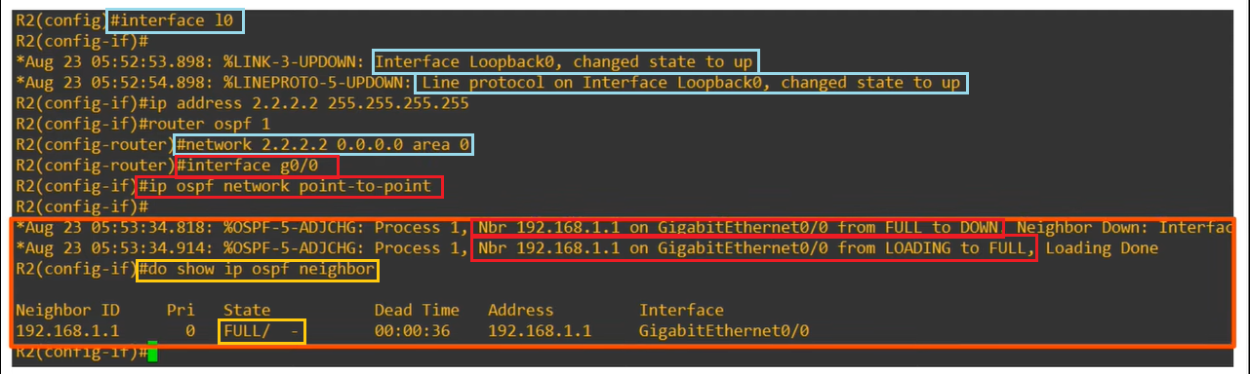 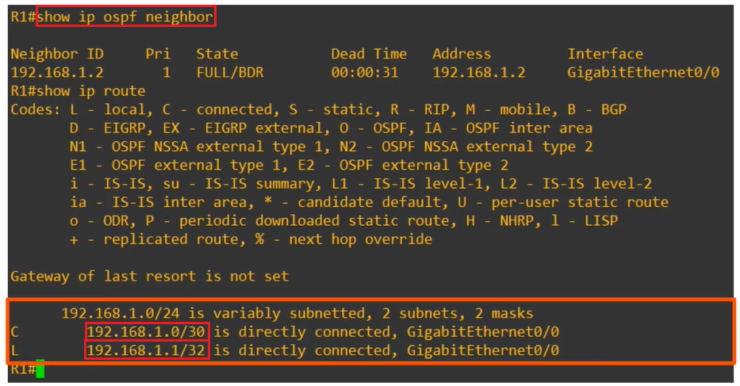

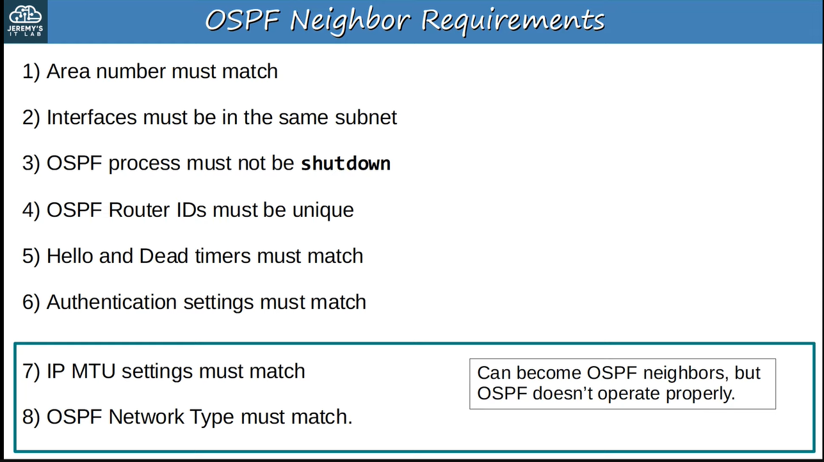

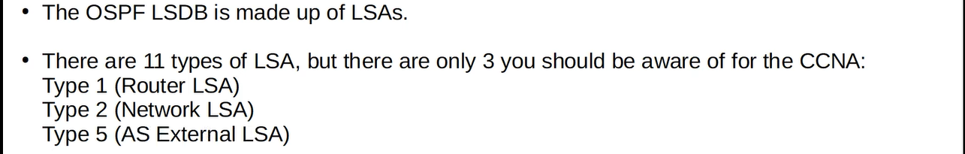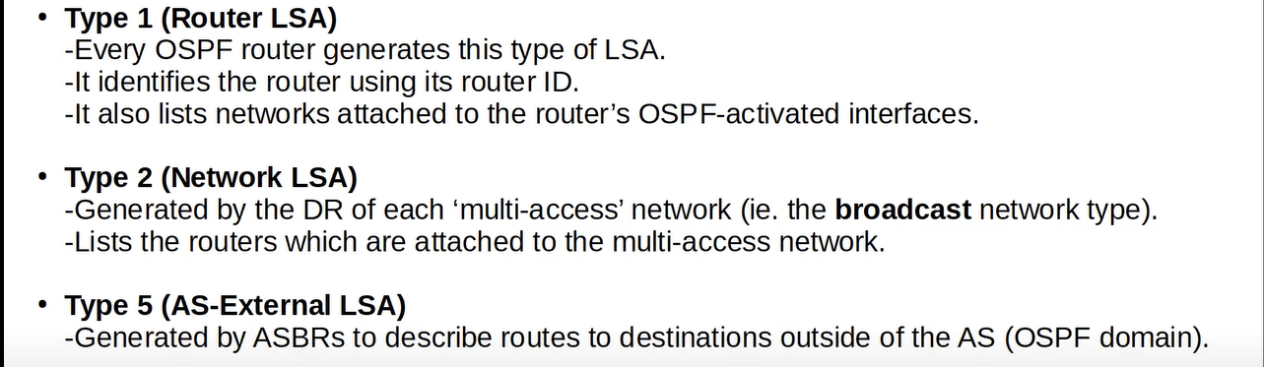**e.g., ↓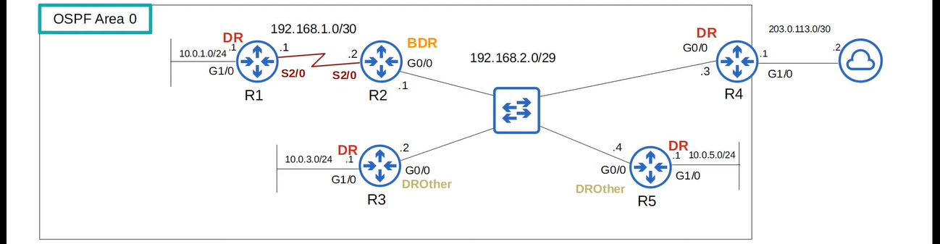in this, all routers will generate “Router LSA” but only R4 will generate “Network LSA” and “AS-External LSA”, because it has only DR that has OSPF neighbours and only R4 has the connection of internet, as you can see ↓**

